SPORT RESEARCH

Leena

Wife carrying (Eukon Kanto)

Country: Finland, Sonkajarvi. Held in July every year.
Starting year: 1992
World record: 2000 – Margo Uusorg (Estonia) and Birgit Ulrich (Estonia), 55.5 seconds.
Rules: A male competitor’s race whilst carrying a female teammate on an obstacle track that is 253.5 meters long. The Track has two dry obstacles and water obstacle that is about 1 meter deep. Contestants run the race two pairs at a time. The prize is the wife’s wight in beer.
Each participant must enjoy themselves.
Only equipment allowed is a belt for the male and helmet for the woman.
The wife to be carried may be your own, the neighbour’s, or you may have found her farther afield she must, however, be over 17 years of age.
Fun facts:
Originally the teams had to be husband and wife. This is not enforced anymore.
The minimum weight of the wife must be 49kg. If she is lighter will the male be given rucksack containing the missing weight.
Lot of competitors take the sport very seriously, but also many teams dress up into funny costumes. The funniest costumes will receive a prize.
Tales say that the sport originates from a robber “Ronkanen the Robber” from 1800’s who used to go around villages and steal food and women, women will be carried away on the men’s backs. Stories also tell that Ronkanen the Robber used to train his thieves by carrying pigs on their backs while running.
Wife carrying contest have taken place also in Australia, United States, Hong Kong, India, Germany, Sweden, Estonia and Latvia.
In India the contest is arranged since 2011 under name Bhaaryasametham.
Most common carrying positions:
Piggyback, Fireman’s carry (Over the shoulder), Estonian-Style (Female upside down on males back).
References: https://eukonkanto.fi/

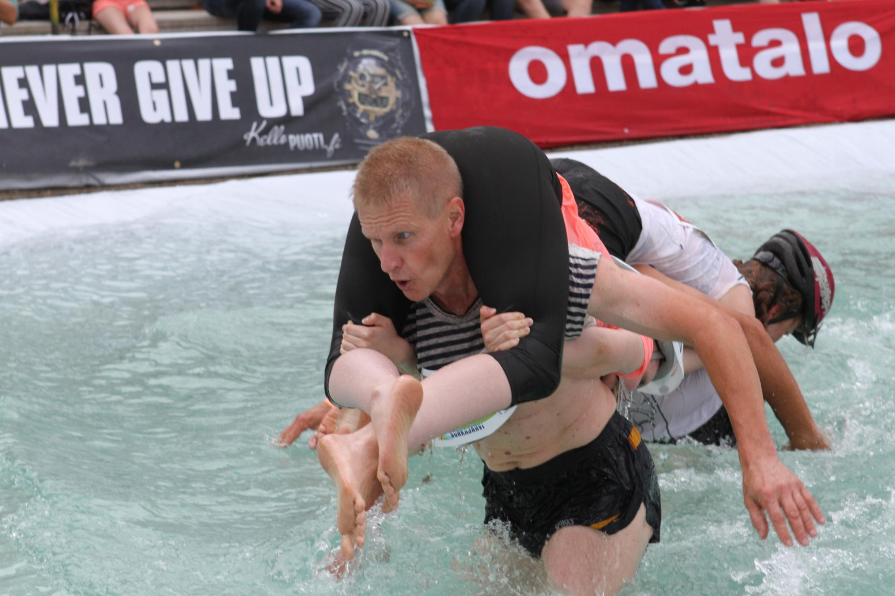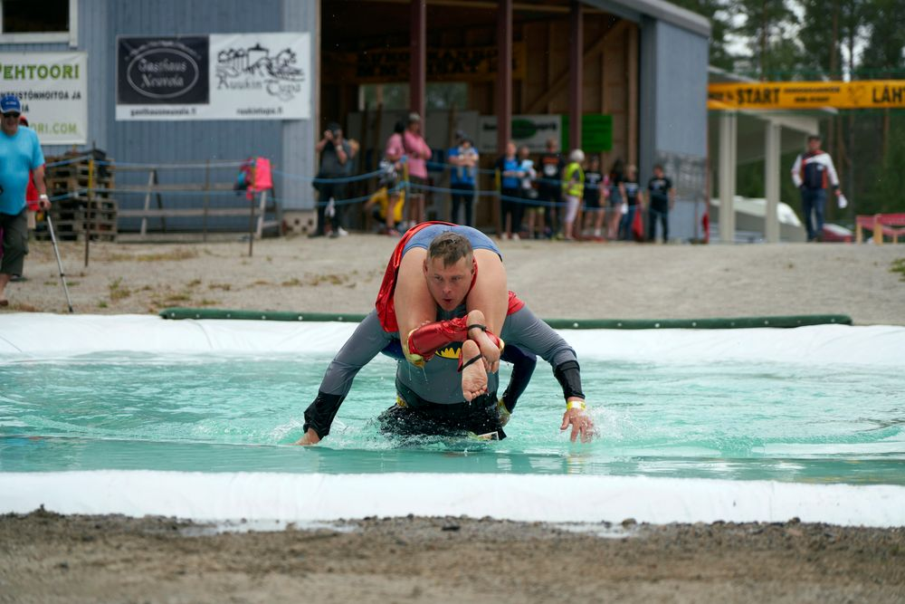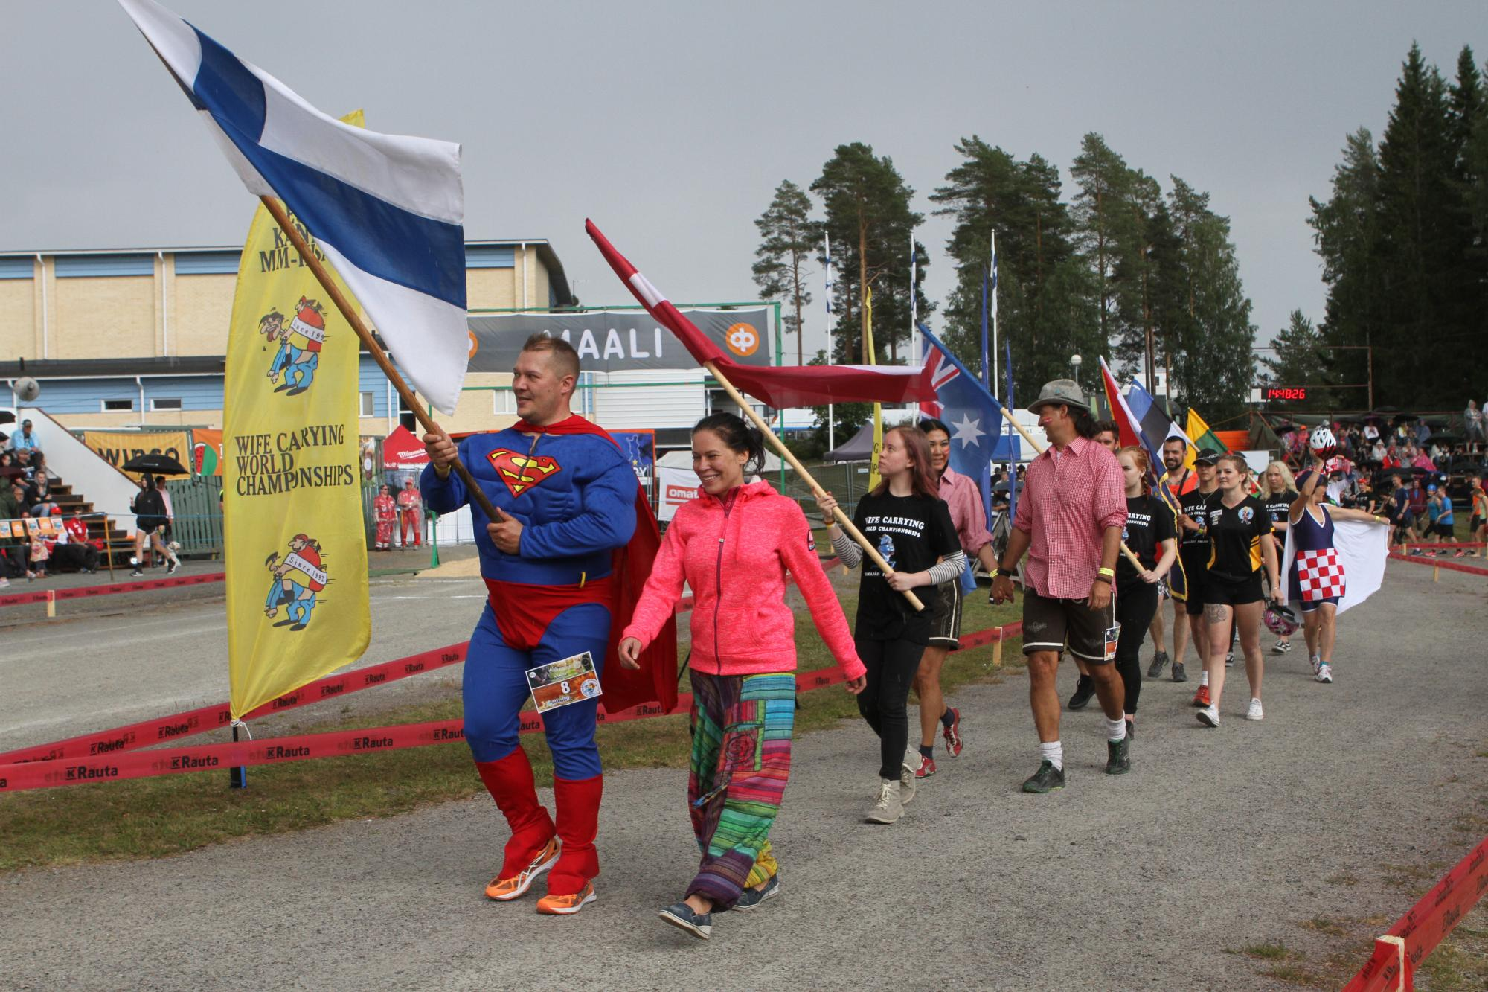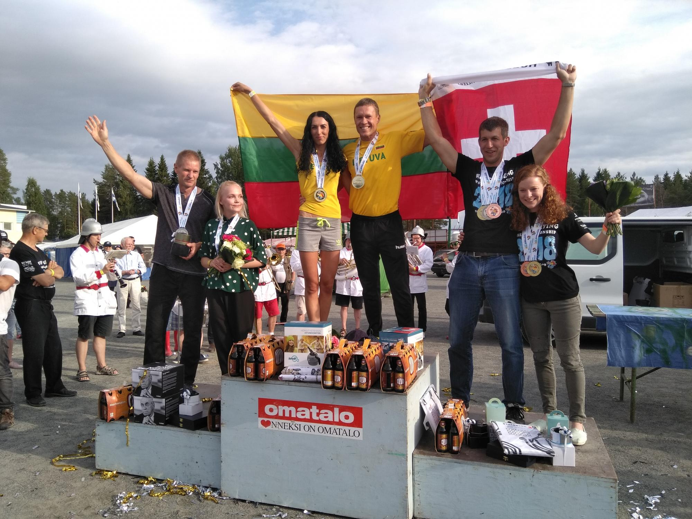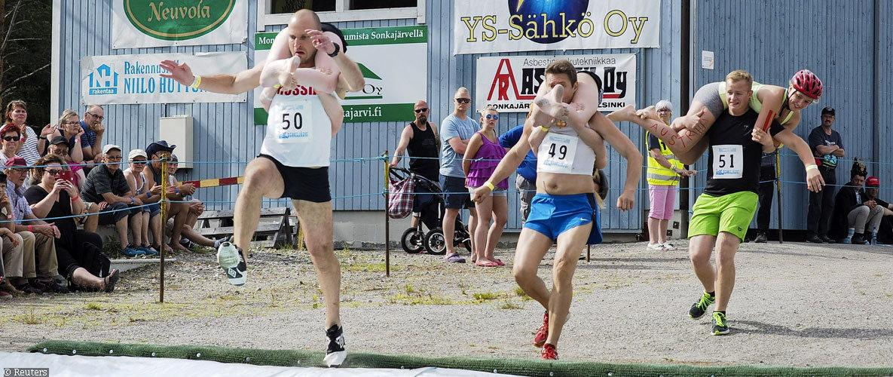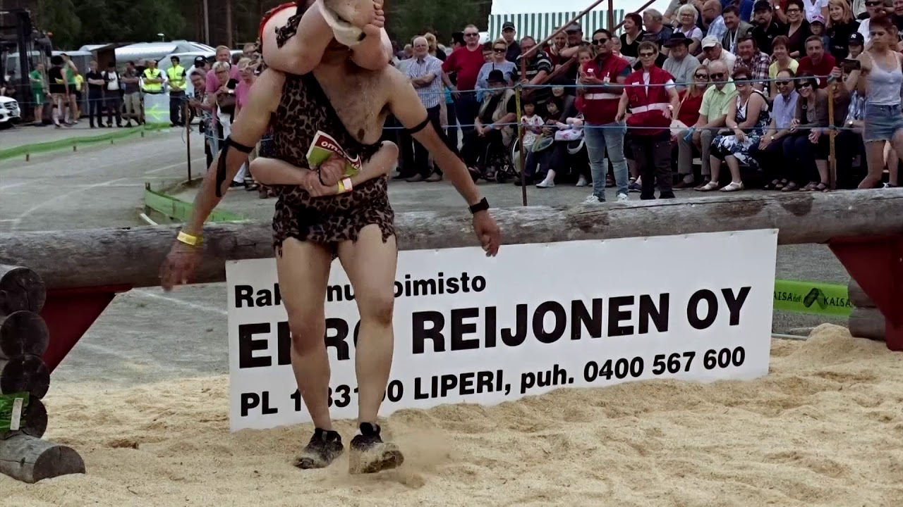
https://eukonkanto.fi/

Hot Dog eating
Country: Brooklyn, NY, Coney Island, United States
Held by Nathan’s Famous Inc. Fast food restaurant chain.
Starting year: 1971, Held yearly on the Independence Day. (Created 1916 and regulated 1997)
Rules:
Only competitors under contract by MLE (Major League Eating) can participate.
Around 20 contestants. Including: the defending champion, winners of a regional qualifying contest for the season, individuals qualifying as one of two wild cards and by those received special invitation by MLE.
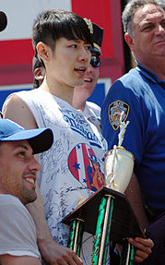
The participants stand behind a long table on a platform with drinks and hot dogs in buns. Water is main drink, but other drinks are allowed. Hot dogs are allowed to cool down slightly after grilling to avoid mouth burns. The contestant that consumes the most hot dogs and keeps them down in 10 minutes is the winner.
Each contestant has designated score keeper counting each hot dog eaten. Partially eaten hot dogs count, the measurement used is eights of the length. Hot dogs still in mouth when time runs if they’re swallowed instantly.
Yellow penalty cards can be given for messy eating. Red card is issued for “reversal of fortune” and will lead to disqualification.
In case of a tie will the contestant see who can eat 5 hot dogs faster. Faster eater will win. Further ties will be done in sudden death of who can eat one hot dog fastest.
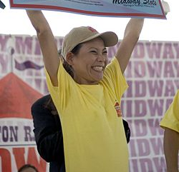
Winner receive a champion belt. Men gets a mustard yellow and women gets pink. Also, cash prizes are given since 2007.
Fun Facts:
The contest time have varied over the years from 3 to 12 minutes. 10 minutes was set as a standard from 2008.
Around 2000s the competition was dominated by Japanese. Takeru Kobayashi won 6 consecutive contests. He’s highest is 50 hot dogs. He has not competed since 2009 as refused to sign the contract with MLE.
First winner of the women’s competition on 2011 was Sonya Thomas, eating 40 hot dogs.
World record held by Joey Chestnut, 74 hot dogs on 2018. Women Sonya Thomas 45, 2012.
References: https://edition.cnn.com/2019/07/04/us/nathans-hotdog-eating-contest/index.html
https://nathansfamous.com/the-stand/hdec-fun-facts/

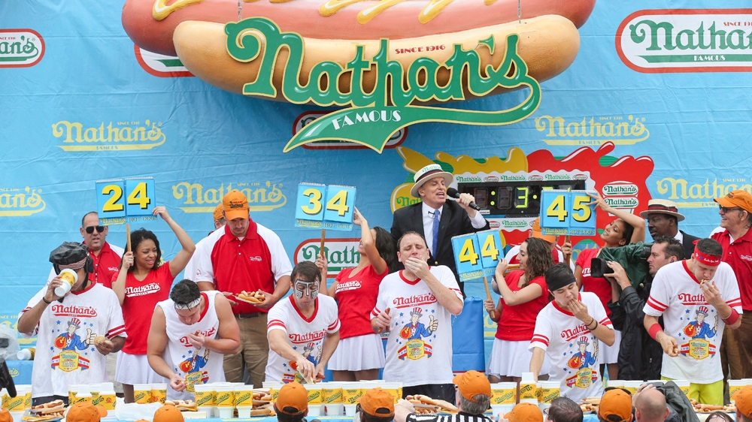
https://doublegsports.com/lets-be-frank-the-nathans-famous-hot-dog-eating-contest-is-must-see/

Ostrich Racing

Country: South Africa
Starting Year:
Rules:
Fun Facts:
Ostrich can run up to 70 km/h, grows up to 2.5 meters and wights 120 kg.
Tales say that the sport is originated centuries ago from Egyptian rulers.
Tourists can ride ostriches as attraction Oudtshoorn, South Africa.
Currently the sport if very popular in the United States, Arizona helds annual Ostritch festival since 2016.
References: https://www.southafrica.com/blog/ostrich-riding-south-africa/
https://www.thedouglasreview.com/ostrich-racing-yes-its-a-thing/
http://www.speedofanimals.com/animals/ostrich
https://www.sa-venues.com/activities/ostrich-rides.htm
https://ostrichfestival.com/

Josh

Pacu Jawi

Caber Tossing

Tuna Tossing

